4S Ranch Summer Horse Camp
Parent Information Packet
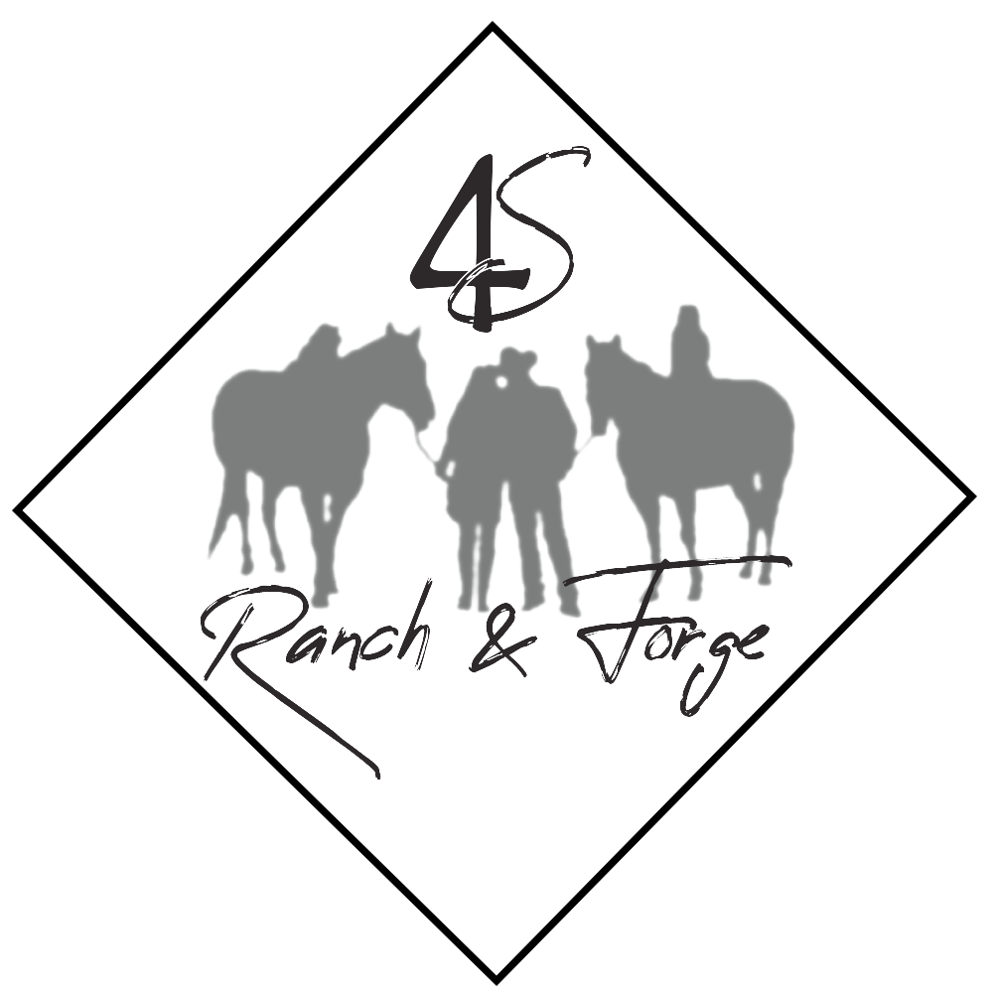
12238 W CTY RD A
Evansville WI 53536
608-235-9404

The 4S Ranch & Forge Summer Horse Camp Experience!
Welcome- we are thrilled you have chosen our equine experience for your child. We are looking forward to creating memories to last a lifetime!
4S Ranch & Forge mission:
4S Ranch is committed to a safe, experiential equine experience that provides children, families, and adults an opportunity to learn communication, self-esteem, confidence, and empathy through horsemanship.
We are excited to provide our mission through our summer camp programs. With integrity and respect, we welcome you and your children to our Ranch!
Sincerely,
Cassandra Strommen- Camp Director

General Camp Overview- Things to Know!
Directions:
From Evansville:
Take 213 West, turn east on County Road A. Continue A about 4 miles. We are on the northside of the road, the third place on the right- just after passing the crossroad Coon Island Road. 12238 W CTY RD A.
From Janesville:
Take HWY 11 toward Evansville. Turn left on H. Turn right on A. Go west on A about 5 miles- our place is on the northside of the road, just past DOHS road. 12238 W CTY RD A.
Questions- call 235-9404

What to bring:
Water Bottle
Hand Sanitizer
Hat/sunglasses
Towel/Swimsuit/water shoes
Sunscreen
Backpack with extra clothes
Closed toed shoes
Bug repellent
Lunch and a snack
*Please label everything- we are not responsible for lost or stolen articles.
What NOT to bring:
IPAD, Phone, or any technology- no time for it!
Anything expensive that you don’t want dirty! This is a ranch with horses, kittens, sand and dirt. We will play, and we will get dirty
New Shoes (they will get ruined.)

What to expect- a day in the life at the Ranch!
*Typical Schedule
**8:45-9:00 Drop off and check in at the ranch!
-Sunscreen put on, lunch in cooler, water bottle filled
9:00-9:30 Opening Circle, Name game, team building game, character value discussion and prayer
9:30-10:30 Horse play- obstacle course, painted ponies, riding, games
10:30-11:00 Snack and free play
11-12:30 Riding & horse play
12:30-1Pm Lunch and free play
1:00 pm-2:45 pm Arts & crafts, all camp games, skits
2:45-3:00 Closing circle and thoughts of the day
*In the event of rain- schedule will change- camp will still be held but we will do indoor activities!

Safety

Helmets:
All campers will wear certified ASTM/SEI helmets. 4S Ranch provides the helmets and all helmets are disinfected between uses. Bike helmets will not be approved. If you choose to have your camper wear their own helmet you must purchase an ASTM/SEI certified helmet.
Closed toed shoes and long pants!
Please absolutely no flip flops or sandals while in the barn area. If you send your child with sandals, they will be able to wear them during games and arts and crafts, but not while near or on horses. Tennis shoes are typically fine for riding. Wear long pants please!
Allergies:
If your camper has any allergies, please make sure the director is aware of them prior to camp beginning. If your child requires an epi-pen, please make sure they have them and are turned into the camp director upon check-in.
Medications:
Because we do not have a nurse on staff, medications will not be administered during the camp day unless otherwise approved by the camp director.
First-Aid:
In the event of an injury not requiring medical assistance, the camp director is certified in First Aid and CPR, and a first aid kit is available in the barn and in the house. If there is an event that requires first aid, you will be notified immediately by phone, and a note will go home with your camper describing in detail first-aid administered.

Medical Emergencies:
If there is a medical emergency, 911 will be called immediately. Our Ranch is serviced by Footville and Evansville EMS- both are between 4-7 miles away. If 911 is called, you will be called immediately.
**It is highly important that your registration has an emergency contact on it- in case you are unavailable.

Buddy System:
All campers will be assigned a buddy daily. Buddies will assist each other in applying sunscreen, bug repellent, getting water, going to the bathroom, and anything else that takes them away from the group. The camp director and any staff that may be assisting should not apply sunscreen, bug repellent or help with bathroom breaks unless there is another adult present. No camper will ever be alone with an adult- there will always be a buddy and counselor.
Staff to camper ratio:
1 staff member to every 4 campers is our typical ratio. Some days, it will be 1:1 and some days it could be 1:4. I will be over staffed according to American Camping Associations guidelines of 1:4, which is safe and proven.
Cats and Dogs- an Essential Part of a Ranch!
4S Ranch is home to two friendly dogs, and various barn cats. While we would like for them to always behave and lay around, that doesn’t always happen- they like to be where the action is- in the barn! If your child is nervous around dogs, or cats, allergic, or simply doesn’t like them- please make sure I know so I can keep them locked up and away from the group! (Caveat- the dogs can be locked up; however, cats have free rein. They usually are sleeping during the day and won’t bother us, but we may see one or two checking out the action!)
Liability Release Waiver:
All campers and parents that visit and are in the barn area need to fill out a liability release waiver. Participants without a signed waiver will not be able to participate. Waivers will be included in this packet and will be available at check-in the first day of camp.

A Word About Horses and their innate behavior:
Horses are animals, and as such, unpredictable. Although 4S Ranch horses are generally well behaved and great with campers, it begs to be said- they are still animals, with their own mind and innate fight or flight responses. Campers will be slowly introduced to horses and horse handling. They will ride, but in a very safe environment- beginning with leading them, round pen work then arena work. Because children do not have the upper and lower body strength of an adult- it is important to give them an experience that builds their self- esteem and confidence, in hopes they love horses for the rest of their lives. Unfortunately, horses are not like motorized toys or carnival rides- we don’t just hop on for a joy ride. Horses are sensitive in nature and mutual respect is taught. Please understand that your child will not be galloping over hills and meadows like in the movies. They will however be having the time of their life learning and growing in empathy, respect, responsibility, and care.
Inclement Weather:
Camp will be held rain or shine- in the event of rain, we will do indoor games, grooming, horse activities in the barn, movies & popcorn, arts & crafts, and more!
In the event of a serious storm, campers will head to our basement (storm shelter) and parents will be notified. Think sunshine and fun!!

Snacks and water:
Please send campers with extra snacks in their lunch- 4S Ranch does not provide snacks.
Water will always be available. If your camper wants juice, pop, or Gatorade- it can be brought from home. All drinks and lunches will be kept in the shade in a cooler.
Behavior and Rules
We are quite certain every single camper will be amazing and follow all the rules- so I even hate to have to include this in the packet!
Campers will be given the following rules on the first day (or in the event of mini-day camps, the only day)
- Safety first. The barn is a place of peace. We will not run, shout, or otherwise “horse play.” (we have plenty of other activities to get the wiggles out!!!)
- When working with horses, always have closed toed shoes and a helmet.
- Follow directions and listen. When the camp director is talking, or if someone is addressing the group, campers must listen and follow all directions. It is as much for safety as it is for respect.
- Campers and staff will respect each other in every way. There will be only kind words and actions, bullying and unkindness will never be tolerated.
- Horses and other animals at the Ranch will be treated with respect and care. They are part of this community and will be treated as such.
- 4S Ranch is home to many. Please respect it by throwing garbage in the trash can, picking up after yourself, and leaving it better than when you arrived. Not your trash? Pick it up anyway
- All campers will respect themselves. Drink. Apply sunscreen. Take breaks. Take care of yourself. If you have a problem or hurt yourself, please tell someone.
- Campers will always be with their buddy or in their group. Never go anywhere alone.
- Stay with the group unless you have permission to leave the group with your buddy. Always ask the camp director if you need to leave the group.

These 9 rules are super important and will help campers have fun and be safe! If the rules are broken- I use 1,2,3 MAGIC to help them get back on track. If that does not work and they have more than 3 time-outs and are disruptive to the group, they will not be allowed to participate for the rest of the week. This is at the camp director’s discretion. There are no refunds for missing camp due to behavior challenges.

Refund and Payment Policy:
There will be no refunds for missed days of camp. If you choose to end your child’s participation, there will be absolutely no refunds. All balances due need to be paid on the first day of camp unless the Camp Director has permitted otherwise.

Questions?
Please do not hesitate to call me- 608-235-9404.
I am looking forward to seeing your camper this summer!!

